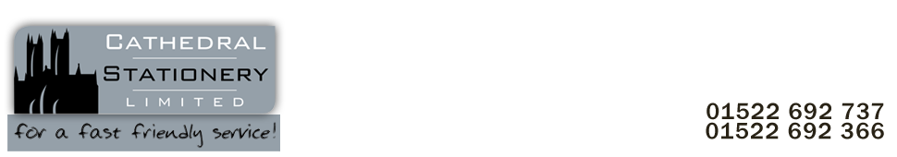

[**sales@cathedral-group.com**](mailto:sales@cathedral-group.com)

**28/10/2022**

**LINCOLN COLLEGE QUOTE REF: JS 092**

**Monks Road, Lincoln, LN2 5HQ**

**PHIL FISHER**

***QUOTATION – 28/10/2022***

***30 x 500 297641 A4 copier paper pale yellow 80gsm £6.77 £203.10***

**TOTAL EX VAT £203.10 TOTAL INC VAT £243.72**

**Kind Regards**

**Jamie Smith Md 01522 692737** [**sales@cathedral-group.com**](mailto:sales@cathedral-group.com)